«TriangleMX» FFGL Mixer

# Introduction

TriangleMX mixer combines two video layers using triangle mesh pattern. The screen area is divided into two triangle strips. Two input layers assign textures to every triangle:

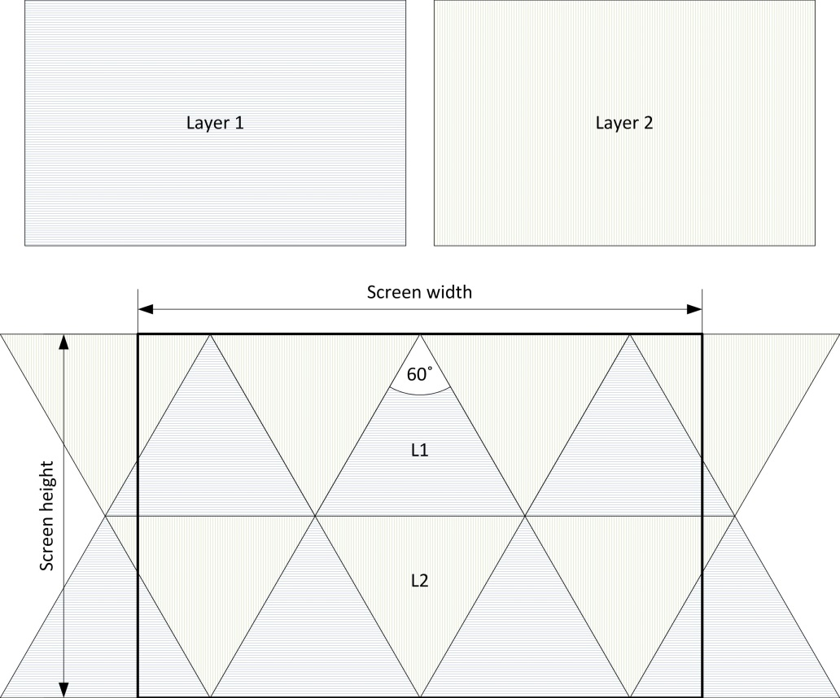

Blending factor controls triangles texture mapping (see «Plugin usage» section).

# Installation

Just copy plugin (dll-file) into Resolume plugin directory. The mixer should appear in blending modes:

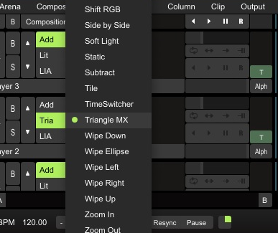

# Plugin usage

Here are some examples of plugin usage. Consider two simple images as input data – first layer is a stack of horizontal lines and second one is composed of vertical lines:

|  |  |
| --- | --- |
| **Layer 1**: | **Layer 2**: |

Mixing with blending factor 0.01 – input images are divided in the same manner as screen area.

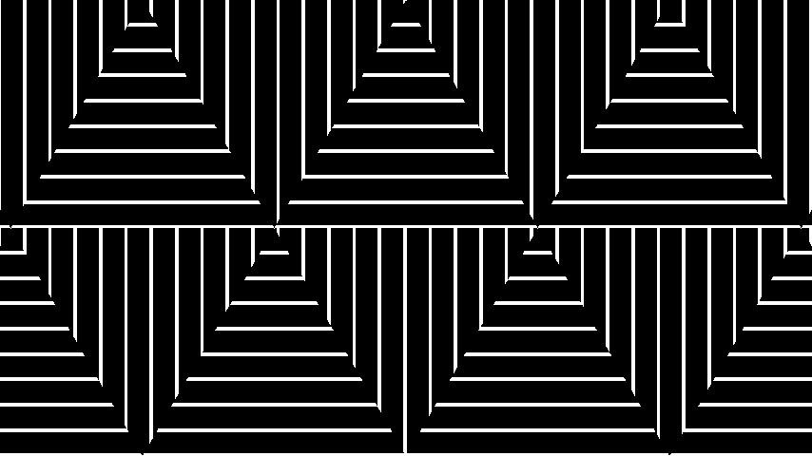

Mixing with blending factor 0.26 – input images are fitted «by height» into central triangles.

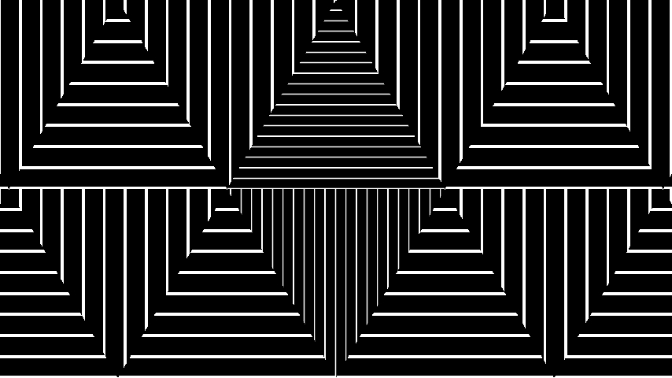

Mixing with blending factor 0.51 – input images are fitted «by height» into six central triangles.

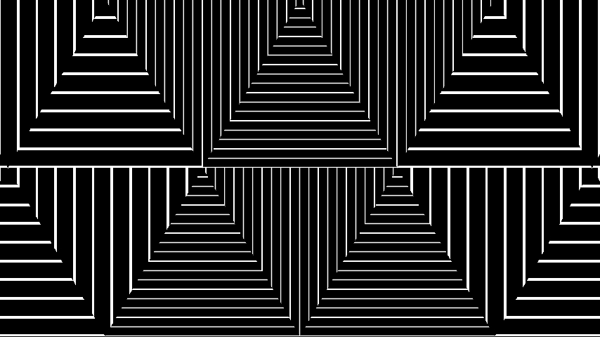

Mixing with blending factor more than 0.77 – input images are fitted into all triangles.

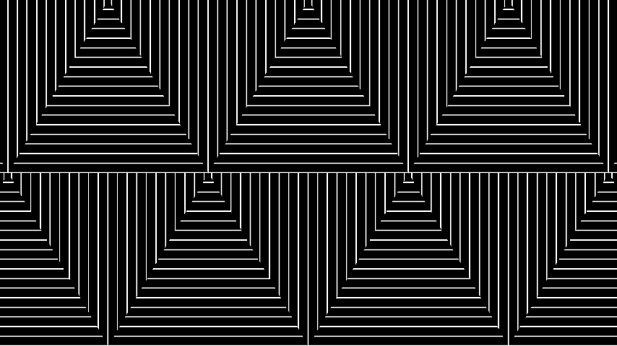

Additional demos available here <http://vimeo.com/85140944>, <http://vimeo.com/84898044>.

# Credits

The idea of the mixer was condensed from Vadim Epstein (vj Eps) demo «Secret in their eyes» (<https://vimeo.com/63057090>).